The Awakening

|  |
| --- |
|  |

Sushil Shakya

Table of contents

The Mirror’s Reflection

First Glance, First Flame

Signs from the Universe

A Moment Stretched in Time

Reality or Illusion

The Mirror’s Reflection

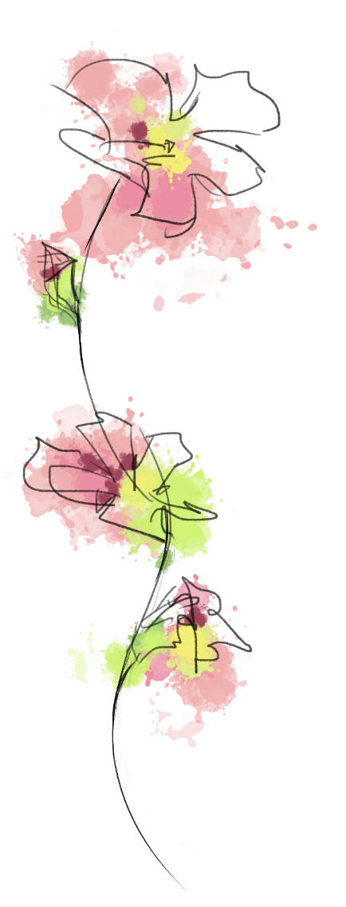In the mornings, he wakes to a life well-worn,  
Routine etched in the lines of his face, forlorn.  
A marriage built on comfort and trust,  
Yet something is missing, buried in the dust.

He moves through days like a ghost in his skin,  
A body present, but a soul trapped within.  
Conversations, just echoes of love,  
What once was passion, now feels like a glove.

Each touch feels foreign, every word rehearsed,  
In this life of predictability, he feels cursed.  
He aches for a meaning, a sign from above,  
To awaken the spirit, to reignite love.

But in the monotony, a whisper he hears,  
A call to something beyond his fears.  
Not in the marriage, nor in the life he knew,  
But in a place where his spirit could renew.

A glimmer of hope in the mirror's stare,  
A hint of something that lingers in the air.  
He seeks the unknown, the path less walked,  
In the heart of Aetherium, where his soul is unlocked.

First Glance, First Flame

In the quiet expanse where shadows play,  
He walks through whispers, lost in the sway.  
Figures move like ghosts in a trance,  
And there, he catches the other—just a glance.

Eyes meet across the softened light,  
In that instant, everything feels right.  
A pull, a tug, something stirs within,  
As if an unseen door opens from deep within.

The other moves with grace, a silent command,  
A fluid rhythm, effortless and grand.  
A magnetism that draws him near,  
In this presence, the world becomes clear.

He wonders, have they met before?  
In another dream, on some distant shore?  
This pull, this draw, feels timeless, profound,  
A connection that makes his heart resound.

In the mundane, a spark is born,  
A flame that flickers, refusing to be torn.  
He watches, he waits, in silent awe,  
For in those eyes, he sees a flaw,

Not in the other, but in himself,  
A life kept hidden, stored on a shelf.  
This other is the mirror, the window, the door,  
To a life he yearns for, and something more.

Signs from the Universe

The universe whispers in strange, quiet ways,  
Moments align, like stars in a haze.  
He enters the space, as the other arrives,  
A choreography of chance, where destinies strive.

Songs on the wind, books on the shelf,  
Each pointing beyond to something beyond self.  
A note in the melody, a line in a verse,  
The subtle hint of something larger, terse.

In dreams, he sees the other, celestial and near,  
In every murmur, in every breath clear.  
A bond not of words, but of cosmic tide,  
As if their souls, by fate, are tied.

But shadows of doubt dance in his mind,  
Are these signs real, or mere patterns he finds?  
He questions the meaning, the path they're on,  
Is this a truth, or a tale he's drawn?

In glances exchanged, in moments shared,  
He feels the universe; he feels dared.  
To uncover what lies in this hidden expanse,  
To reach out, and take that trembling chance.

Yet reality blurs, as does his sight,  
Is this connection a beacon or just night’s light?  
In seeking answers, in chasing more,  
He finds himself at the mystic door.

Is he led by the stars, by the hand of fate,  
Or merely a dreamer, unsure of the gate?  
In the threshold’s silence, he stands alone,  
Questioning the journey, the unknown.

A Moment Stretched in Time

 There are moments when the world seems to halt,  
When every heartbeat comes to a fault.  
He senses it each time the other steps near,  
An electric pulse, a silent cheer.

The other moves like a whisper in the wind,  
An effortless grace, unconfined and unpinned.  
Each gesture leaves a trace, a ripple, a mark,  
An echo that travels through the quiet, dark.

He glimpses the other in fragments, half-seen,  
As if they've existed in worlds in between.  
Each encounter feels both new and old,  
A story retold, in fragments of gold.

Was the other always a shadow unseen,  
A figure of dreams, a link yet unclean?  
Or did they appear like a phantom, a muse,  
A fleeting image in the kaleidoscope hues?

Time itself seems to warp and unwind,  
In the other’s presence, all rules unbind.  
Moments stretch out, linger, expand,  
As if reality can't withstand.

Is the other a guide, a phantom, a muse?  
Or another illusion destined to lose?  
He reaches out but holds back in fear,  
Caught in a trance, between far and near.

In that stretch of time, in that breathless space,  
He glimpses a truth, a hint of grace.  
A connection pure, a bond untold,  
A secret yearning, a story bold.

Reality or Illusion

 Reality trembles like leaves in the breeze,  
Moments slip by, leaving questions uneased.  
He sees the other not just in form,  
But in shadows, reflections, the storm's quiet warm.

He questions his mind, his heart’s deception,  
Is this real or his own perception?  
Did the other truly smile, glance his way,  
Or is it fantasy that leads him astray?

He drifts through life, half-awake, half-dream,  
Reality fraying at every seam.  
The world around him begins to bend,  
As if sanity itself is at an end.

Small shifts appear, like cracks in a mirror,  
A glance, a whisper, a feeling unclear.  
Is it fate that teases, or his mind’s own play,  
He can't tell what's real, what's here to stay.

The other becomes his axis, his pole,  
Around which his world begins to roll.  
A thread of fate, tangled and tight,  
Drawing him deeper into the night.

He wants to believe in signs, in fate,  
In a universe with plans innate.  
But as reality blurs, and illusions grow,  
He stands on the edge, afraid to know.

For in the other, he sees a truth,  
A reflection of longing, a quest for youth.  
And as the world slips, he's left to ponder,  
Is this love, or just a spell he's under?

